Motivation and Self realization is key to bring Change
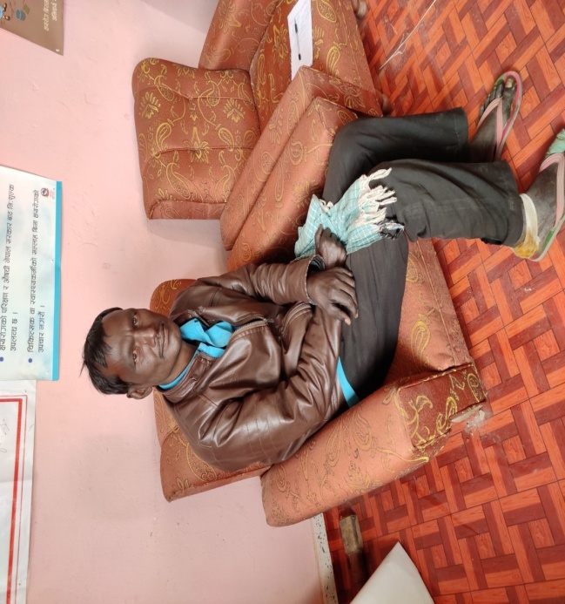
Ram Kishor Pasi, a habitant of Shivabhari, ward no. 9 of Maharajgunj municipality, lives with his 7 family members. He used to work in Mumbai, India. While working in Mumbai he got some patches in his body and spent around Rs.8000 for his treatment but he couldn't recover so, he returned home. In Nepal also, he tried different medication as well as went to different kinds of traditional healer (Sokhas) and spent around Rs.15000. When he did not get any change and got worsen condition, he went to Palpa where he was diagnosed as leprosy and doctor recommended him 12 months medication and to take free medicine from his nearest health facility. He went to district hospital of Kapilvastu and told his problem. when the doctors from kapivastu hospital suggested him similar thing then, he started taking medicine from Hardauna Health Post of Maharajgunj.
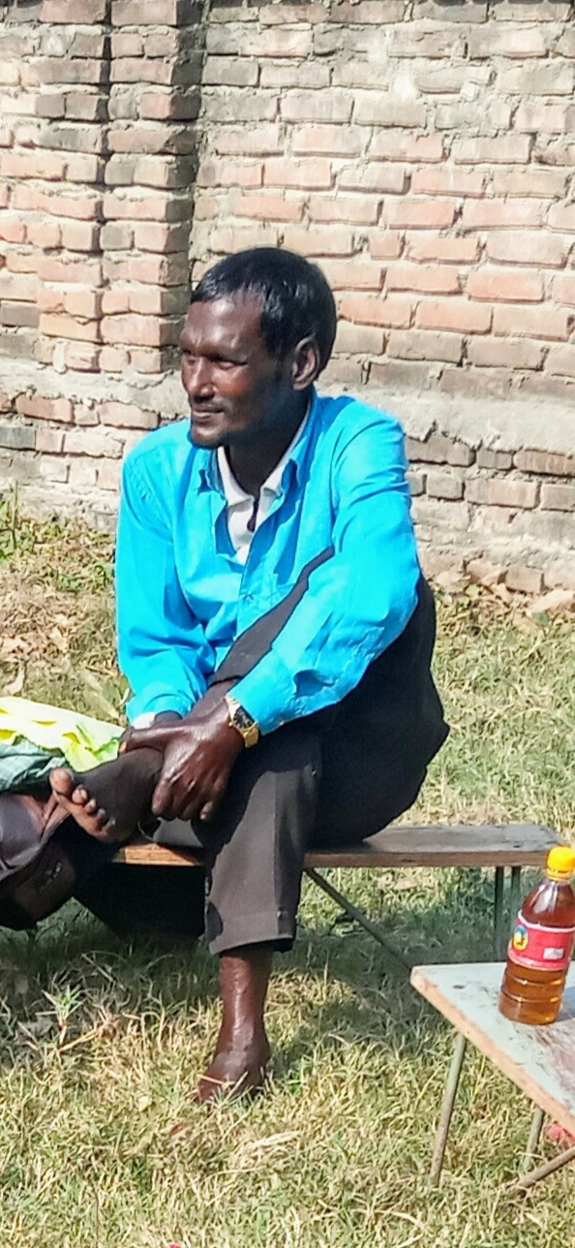
He continued medicine for 6 months and went back for work in Mumbai. There he again faced problem, there were wounds in his legs. He went to Kotiya bazaar of india and treated his wound. He stoped taking medicine of leprosy from that time. Community mobilize of EHP met him during the home visit of NTDs affected people and luckily he was back to home. While taking whim him, it was identified that he has taken medicine for only 6 months. After a long discussion and counseling he was ready to continue his medicine. So, CHM supported him to continue medication by coordinating with health post. Till the date due to leprosy, his hand and eye was affected.
With a regular counseling and motivation, he was enrolled in the self help group and 3 days self care training organized by essential health project in Maharajgunj-2, Gaidhawa. Now Ram kumar Said," I never thought this much, importance of medicine, daily care, etc. Now I know many things. I regularly take care of my wounds, legs, hand and eyes, I do exercise regularly. I blink my eye continuously as our trainer taught think and blink. I have seen change in a short period. I want to thank Prabhu and the team as I got change to know how to care myself".

