Change seen in Health Facility Operation and Management Committee after the training.
Every health facility has a Health Facility Operation and Management Committee, a tier to manage quality health service delivery. Essential Health Project implemented by Kalika Self- Reliance social Centre in partnership with FAIRMED is supporting for approval of a new model HFOMC guideline from municipal level and also organizing 2 days training to newly selected HFOMC members.
Shivaraj municipality, one of the project implemented municipalities of Kapilvastu, has also approved and reformed all the HFOMCs of all health facility. Shivagadi Health Post situated in Shivaraj municipality ward no.9 also formed the HFOMC as per new guideline. Project supported to organize 2 days tr to HFOMC training members of Shivagadi HP on 2076/08/09 which helped to increase their active participation toward health sector. Before the training, the concept of HFOMC members was just limited on conducting meeting only when needed and thought that the main responsibility towards health is up-to health in-charge. HFOMC were unaware of their roles and responsibility. They used to further thought that they have to just sign different decisions for health.
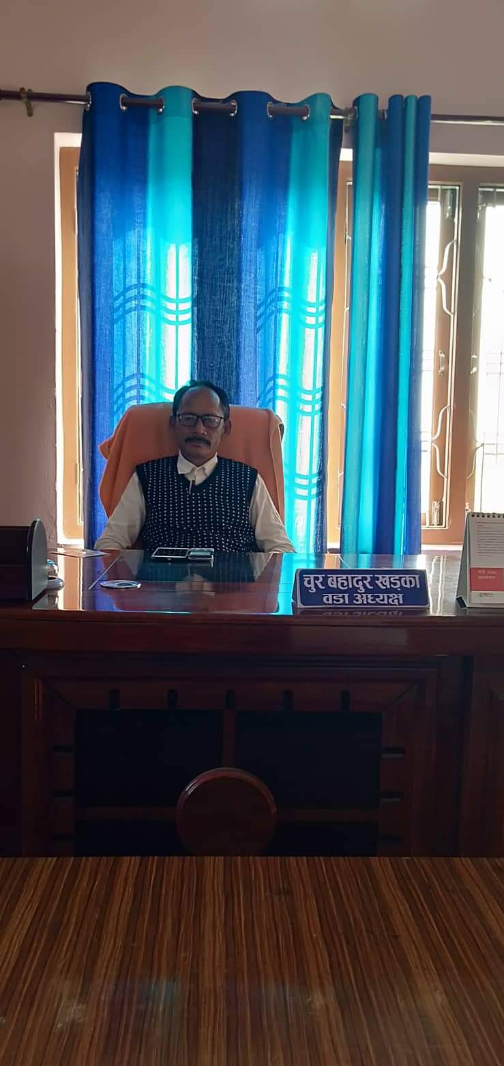
Health was a less focused area. No any specific concern were raised for quality health service delivery, less budget was allocated for health sector, activities were concentrated only on infrastructures, less priority was given to health related program. This situation of health sector was understood by the HFOMC members of Shivagadi when they actively participated in the 2 days training regarding roles and responsibilities of HFOMC members. Now, the situation has been changed. HFOMC are regularly conducting monthly meeting and discuss on the health issues, advocacy and regular support to deliver quality health services to community.
"Committee has never get any kind of training, orientation about their roles and responsibility due to which all were inactive. Now, we are trained and well aware about our responsibility. To deliver the quality health services and ensure access to those services, we have allocated 9 lakhs 50 thousand budget for the establishment and regularity of Community Health Unit at Dhankhola and we are regularly advocating for improving quality health services. Now onward HFOMC will actively work on health sector to ensure quality and accessible health services." said Ward Chairperson as well as Shivagadi Health Facility Operation and Management Committee Chaiperson Mr. Chur Bahadhur Khadaka. He further expressed his gratitude to Kalika and FAIRMED for empowering the committee and regular support.
Chur Bahadur Khadaka
Ward Chairperson and HFOMC Chairperson, Shivagadi
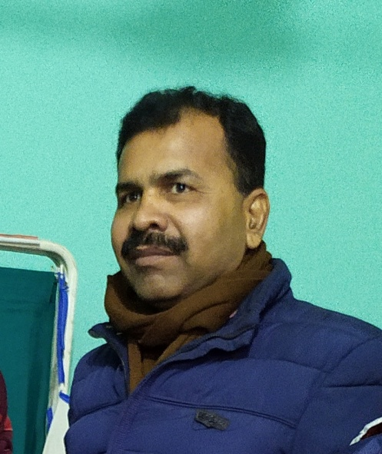
Similarly, Health post In-charge Birendra Mishara also shared his thankfulness to Project team," previously,it was very difficult to organize meeting with HFOMC team. Now, they are self active and are regularly monitoring and ensuring the health programs & services in community level. HFOMC members are now visiting mother's group meeting, Out reach clinic as well as immunization centers. Their active participation in health has encouraged our health workers to work actively."
The realization of roles and responsibilities by HFOMC members has brought a positive change in the health system and health service delivery of Shivagdi HP.
Birendra Mishra
HP In-charge, Shivagadi

